***Object Oriented Programming Lab 9***

***Niranjan Dhokarikar 65***

***ME-A Batch 3***

**Problem Statement ->**

Write a java program which implements interface to create multiple threads and synchronize their working.

Code ->

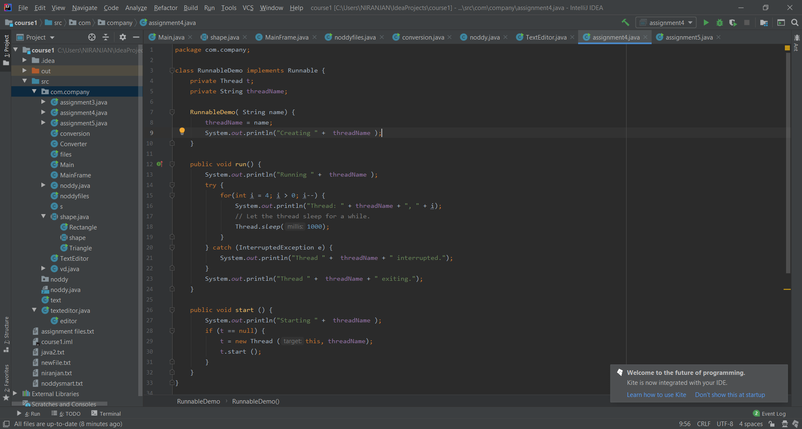

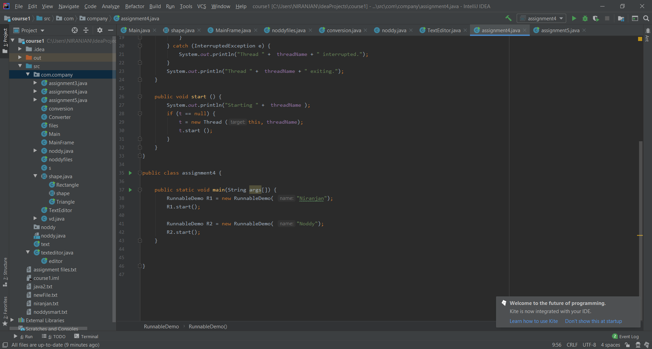

**Output of the Following Program ->**

